Family Instructions for Distance Learning
Dear Families,
I hope this letter finds you safe and healthy. We are exploring unprecedented times in Education. This letter is to give you instructions on how to access Summer Camp Distance Learning beginning on June 2.
Here is the schedule for our school.
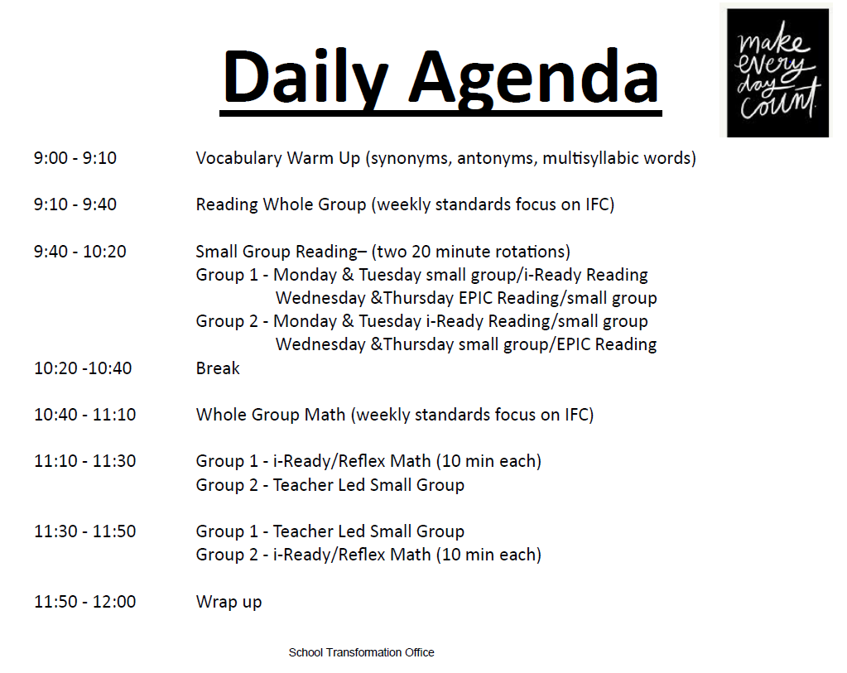
When accessing your teachers live lessons, students must access their canvas Course by
Accessing LaunchPad, clicking on Canvas, and accessing the School’s Student Body Page and clicking on Distance Learning at their assigned time.
Please see instructions with pictures on the next page.

For questions, please call Mrs. Allyson Prince (Assistant Principal) #407-296-6490.

Access Launchpad. launch.ocps.net Students need to use their Student ID and password (birthday in the format yyyymmdd).

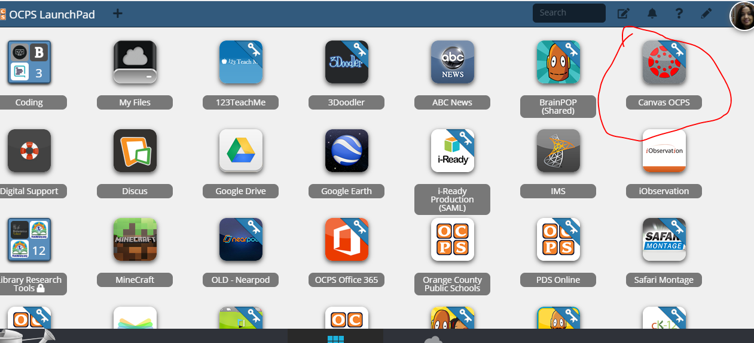
- Click on Student Body Course,
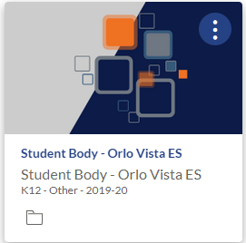
Click the Distance Learning Icon, and choose the teacher. You can choose Live Lesson at your assigned time or click on recorded lessons for previous lessons.
